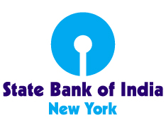

State Bank of India, located at 460 Park Avenue, New York, NY 10022 seeks a full-time Manager-Regulatory Reporting in Accounts Department to prepare Regulatory Reports, Financial Reports for Month end/Quarter end/ and Annual Closing.

5 to 7 years relevant banking experience in the Financial and Regulatory Reporting to Federal Reserve Board (FRB) and other banking regulators. Must be able to monitor all Regulatory returns for accuracy, manage work for meeting all regulatory return deadlines. Excellent interpersonal and communication skills with proactive approach and thorough knowledge of the industry best practices. Must be able to undertake periodic self-assessment on key controls to assess the proper functioning and adequacy of Regulatory and Financial reports.

The position requires at least a Bachelor’s degree, preferably Finance or Accounting major. Please refer to our website : https://sbinewyork.statebank/careers

Candidates wishing to apply, please send resume to: vppna.nyb@statebank.com, vpaccts.nyb@statebank.com on or before March 26, 2023.

