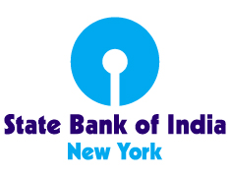

STATE BANK OF INDIA
460 Park Avenue, New York, NY 10022

HIRING

STATE BANK OF INDIA, NEW YORK BRANCH IS LOOKING TO HIRE SUITABLE CANDIDATES FOR THE POSITION OF
ENTRY-LEVEL ASSOCIATES

Associate (General Banking), the candidate should possess minimum educational qualification of a High School Diploma and be capable of working in a computerized environment.

Must be flexible and work well with a diverse workforce. The role requires to work in office work set up.

The positions have an annual base salary of $32,760 ($18 Per hour) plus group life insurance, health and dental insurance (fully paid for by the bank) and 401k benefits.

Interested candidates, please submit your resume to:

pna.nyb@statebank.com
vppna.nyb@statebank.com and

on or before February 10, 2023

STATE BANK OF INDIA IS AN EQUAL EMPLOYMENT EMPLOYER

ALL CANDIDATES MUST HAVE VALID AUTHORIZATION TO WORK IN THE US

